Object Oriented Analysis & Design

XperTime Employee Management System

Final Report

Company
Triple A Solutions


Members

Asim Shehzad (i14-0204-F)
Arveen Kumar (i14-1615-F)
Ali Murad (i14-0164-D)

Table of Contents
Honor Code.....................................................................................3
1. Introduction.................................................................................4
1.1 Problem Statement...........................................................4
1.2 Project Title.......................................................................4
1.3 Scope.................................................................................4
1.4 Objectives..........................................................................4
2. Vision...........................................................................................5
2.1 Introduction.......................................................................5
2.2 Business Opportunity.......................................................5
2.3 Problem Statement...........................................................5
2.4 Scope.................................................................................5
2.5 User Level Goals...............................................................5
2.6 Summary of Benefits........................................................6
3. Use Case Diagram......................................................................7
4. High Level Use Cases.................................................................8
5. Expanded Use Cases................................................................11
6. Supplementary Specifications.................................................23
7. Glossary.....................................................................................27
8. Domain Model...........................................................................28
9. System Sequence Diagrams....................................................29
10. Operation Contracts...............................................................35
11.Sequence Diagram
12. Class Diagram.........................................................................41
13.Package Diagram
14.Deployement Diagram………………………………………………

Honor Code

"I am a person of integrity. I pledge, as a member of the NUCES-FAST University community, to abide by and uphold the honor code. All submitted work is done by me and I have not plagiarized or cheated from other sources"

Member 1 Signature ___________________
Member 2 Signature ___________________
Member 3 Signature ___________________

1. Introduction

Almost every major enterprise has an automated management system with quite a lot of modules. Each module handles a specific part of the enterprise. Systems like these increase efficiency of the company by a big factor. All the trivial office work and clutter is reduced saving the company a good deal of resources. Since these systems are mostly divided into sets of modules, the designing phase is actually much more crucial than the implementation itself. Therefore such a project can actually prove to be a beneficial for exercising OOAD. Some of the modules that our system will contain are; attendance management (with RFID), payroll/salary calculation, leaves/holidays, projects worked, etc. These modules can complete one set of the complete system, which is, employee management.

1.1 Problem statement

A large number of small to medium sized organizations cannot afford complete ERPs, and/or don't have enough resources to train each employee to work on an ERP. Smaller, affordable, and simpler automated employee management system can prove to be the solution for such organizations.

1.2 Project Title

XperTime – an employee management system

1.3 Scope

The scope of the project is to automate an organization's employee management system comprising of modules such as attendance management, payroll processing, and leave/holiday management. Such a system can be targeted at small to medium sized enterprises that cannot afford to buy/build complete ERPs. Employee management is big enough to consume resources of an organization but an automated employee management system is not big enough to require a big budget for implementation.

1.4 Objectives

An employee management system is perfectly suited for small to medium sized organizations that cannot afford complete ERPs. Such a system will solve all the repetitive tasks and save resources. Manual work will be reduced by a good factor. With a platform that provides an employee with a quick solution to trivial issues that would otherwise require contacting the HR, such as taking leaves. All basic tasks can be done by an employee over a single interface. Moreover, additional features can be implemented that actually notify employees whenever they're not being productive, or have been missing work frequently. Also, a work related module that keeps track of the project an employee works on can help the supervisors assess that employee's productivity. This can serve as proof for workers that deserve bonuses. To summarize it all, an employee management system can provide an affordable system for a small organization that can save it the troubles of manual, trivial, work.

2. Vision

2.1 Introduction

Almost every major enterprise has an automated management system with quite a lot of modules. Each module handles a specific part of the enterprise. Systems like these increase efficiency of the company by a big factor. All the trivial office work and clutter is reduced saving the company a good deal of resources. What we envision is a system that is best suited for the needs of a small to medium sized enterprises. Such companies do not have the resources to buy or develop full scale ERPs. We wish to develop a system that automates almost every trivial task that ends up consuming more than a few resources. The end goal is to create an extremely simple, fast, and reliable system. Some of the modules that our system will contain are; attendance management (with RFID), payroll/salary calculation, leaves/holidays, projects worked, etc. These modules can complete one set of the complete system, which is, employee management.

2.2 Business Opportunity

By creating a simple EMS, we can target any middle sized organization that does not wish to spend majority of it's resources on full scale ERPs, yet still wants to have a fast, reliable, and simple system that serves all basic employee management needs such as attendance, salary calculation, managing leaves and projects etc. With the increasing number of start ups today, it would be a great opportunity for such a system to be created.

2.3 Problem statement

Small to medium sized organizations cannot afford complete ERPs. Even if an ERP is implemented it would take a lot of time in order to train the employees. Such organizations do not have enough resources to train each employee to work on an ERP. Another problem is the manual work each employee has to deal with on a daily basis, which hinders his/her productivity. For instance, if employees wish to apply for leave, they would have to go through the manual process and deal with HR and ask their supervisor. Automating this whole process can save the employee quite some time. Therefore, a smaller, affordable, and simpler automated employee management system can prove to be the solution for such organizations.

2.4 Scope

The scope of the project is to automate an organization's employee management system comprising of modules such as attendance management, payroll processing, and leave/holiday management. Such a system can be targeted at small to medium sized enterprises that cannot afford to buy/build complete ERPs. Employee management is big enough to consume resources of an organization but an automated employee management system is not big enough to require a big budget for implementation.

2.5 User-Level Goals

Employee: login, view attendance, view salary & deductions, apply for leave, mark attendance, work over time.

Manager: View own attendance and employee's (under supervision) attendance, approve/disapprove application for leave. (since a manager is also an employee, the rest of the goals remain same as for an employee)

Administrator: Manage (add/delete/update) employee accounts, generate enterprise wide attendance reports.

2.6 Summary of Benefits

Supporting Feature | Stakeholder Benefits
System will provide RFID attendance | Manual attendance is not required
Overtime work will be determined from employee's arrival and departure times | This will eventually help in salary calculation
Warnings will be generated if the employee arrives late over a period of time. If the late arrivals continue, the supervisor will be alerted | The employees can be made to be more punctual
Salary will be calculated automatically. Deductions will be made if a degradation of performance is observed through the employee's attendance and hours worked on projects. Bonus for working overtime will be added in the salary automatically by the system, according to a set criteria | Instead of manually having to calculate attendance and warning the employee, the system will automate the process and every employee will be judged equally.
Leave management module provides a complete interface for requesting leaves. A supervisor can approve/disapprove (probably after seeing how many leaves have already been taken) the request. | Nor the manager, and nor the employee will need to do any manual work except for pressing a button.

3. Use Case Diagram

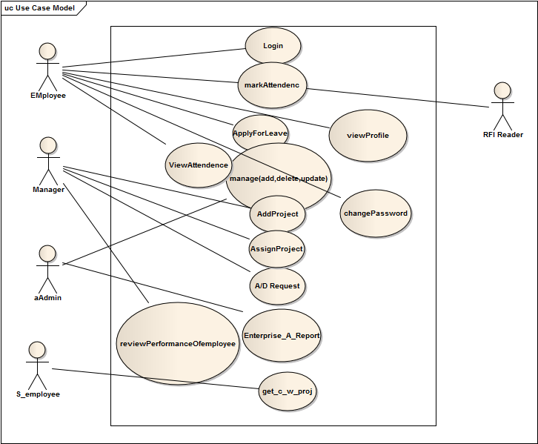

4. High-level Use Cases

Following are several high-level use cases related to the XperTime Employee Management System as identified initially:

Use Case 1

Use Case Name: Login

Actor(s): User

Purpose: To let the user log into his account

Description: The user enters his username/ID and account password into the system. The system logs in the user. The home page of the user is displayed.

Use Case 2

Use Case Name: Mark Attendance

Actor(s): Employee, RFID Reader

Purpose: To mark the attendance, along with the arrival time, of the employee when he interacts with the RFID reader

Description: The user (it can be any employee i.e. manager, admin etc) interacts with the RFID system. The reader records the time and date of arrival and stores into the system database.

Use Case 3

Use Case Name: View user's attendance

Actor(s): User

Purpose: To allow the user to see his own attendance

Description: The user views his own attendance by clicking a 'view attendance' button on the interface.

Use Case 4

Use Case Name: Apply for leave

Actor(s): User

Purpose: To allow the user to apply for leave

Description: There are multiple types of leaves such as sick leave, and casual leave. The user chooses from the given list of leaves and also add the number of days. The system also sends a notification to the employee's manager.

Use Case 5

Use Case Name: Approve/Disapprove leave application

Actor(s): Manager

Purpose: To allow the manager to approve or disapprove the application

Description: The manager approves the leave application of the employee. To aid the manger in making the decision, the whole attendance report of the employee is attached with the notification.

Use Case 6

Use Case Name: Add Project

Actor(s): Manager

Description: The manager interacts with system and add project.

Use Case 7

Use Case Name: Generate enterprise-wide attendance report

Actor(s): Administrator

Purpose: To allow the administrator to view the complete attendance report of each and every employee

Description: The administrator gets the report on the basis of multiple options such as between two dates, specific days, and more. If the administrator wishes to get the complete attendance between two dates, a report will be generated that contains the summary of each employee's attendance between the selected dates.

Use Case 8

Use Case Name: changePassword

Actor(s): Employee

Description: The employee changes the password by entering his/her pervious password.

Use Case 9

Use Case Name: View Profile

Actor(s): Employee

Description: The employee views the own profile after signing.

Use Case 10

Use Case Name: Get current Working project

Actor(s):Simple Employee

Description: The employee views the own currently working project after signing.

Use Case 11

Use Case Name: Review performance of an employee

Actor(s): Manager

Purpose: To allow the manager to review performance of an employee under his supervision

Description: The manger reviews the performance of an employee by selecting the generate performance report against an employee. The report would contain complete details of the employee and the work he/she does.

Use Case 12

Use Case Name: Add/Delete/Update Employee account

Actor(s): Administrator

Purpose: To make the administrator able to add, delete, or update an employee's account

Description: The administrator adds a new account once a new employee is hired. When an employee leaves the company, the administrator can delete the account. If a certain employee requires that his information be changed/updated, the administrator can do so.

Use Case 13

Use Case Name: Assign a project to an employee

Actor(s): Manager

Purpose: To assign a project to an employee

Description: The Manager assigns a project to an employee (after manually receiving the instructions to do so or on some other criteria). The project is added in the employee's list of projects. The manager also sees the employee in the list of employees that he supervises.

5. Expanded Use Cases

Following are the expanded versions of the high-level use cases that were identified previously for our XperTime Employee Management System:

Use Case 1

Use Case Name: Login

Primary Actor(s): User (Administrator, Manager, Employee)

Purpose: To let the user log into his account

Stakeholder & Interests:

- User: The user wants to log into the system and view his own interface (which differs slightly for each type of user)

Precondition: User must be registered. The account must not be disabled.

Postcondition: User successfully logs into the system and can view his respective interface.

Scenario:

Actor Action | System Response
1) The actor enters his/her username and password into the fields displayed by the system | 2) System verifies entered name and password values from database
 | 3) System grants the user access to services according to his authorization and displays the respective interface

Extension:

a. The user enters incorrect information (username, password or both):

- The sytem prompts the user to try again with a message informing the user which field(s) is/are incorrect. This step is repeated until the user enters correct information. Maximum 6 tries are allowed (for security purposes).

b. The user is currently disabled:

- The system informs the user that the account is disabled/frozen, and that the user should go to the administrator.
- The admin is informed automatically.

Use Case 2

Use Case Name: Mark Attendance

Primary Actor(s): Employee, RFID Reader

Purpose: To mark the attendance, along with the arrival time, of the employee when he interacts with the RFID reader

Stakeholder & Interests:

- Employee: Wants accurate time and date of arrival when attendance is marked through the RFID reader.
- RFID Reader: The RFID reader/scanner's goal is to add the exact time and date of arrival of the employee in the database which is handled by the system.

Precondition: User must be registered. The account must not be disabled.

Postcondition: The correct time and date of arrival of the employee is sent to the database along with the RFID number. Attendance of the employee against the given RFID number is updated.

Scenario:

Actor Action | System Response
1) The employee places ID card against the RFID reader.
2) RFID reader sends information to the system database. | 3) System updates attendance against the given RFID number.

Extension:

a. The employee is not registered:

- The RFID reader may or may not make a sound to inform the person. The system will not update. Step is repeated as long as RFID reader does not recognize.

b. The employee account is disabled:

- A notification is sent to the administrator. The system does not update.

c. The system fails to update:

- Back up systems are kept and the attendance is marked in a back up database. RFID reader can also hold the information in its memory.

Use Case 3

Use Case Name: View user's attendance

Primary Actor(s): User

Purpose: To allow the user to see his own attendance

Stakeholder & Interests:

- User: Wants to view his/her complete attendance. The attendance should contan all the necessary details such as date and time of both arrival and departure.

Precondition: User must be signed in.

Postcondition: The user can see his/her own attendance.

Scenario:

Actor Action | System Response
1) The user clicks 'View Attendance'.
2) The user selects star date and end date.
 | 3) The system interface displays the attendance between the entered dates. Default date is from the first record to the final.

Extension:

a. The system fails to display the attendance.

- The user clicks 'View Attendance' and enters information again.
- The user logs out and logs in again and repeats step 1.
- The user uses troubleshoot function where an option of system restore is made available.
- The administrator can be informed who can confirm if the problem is local to the user or with the system itself. The admin can repeat step 3 from his interface.

Use Case 4

Use Case Name: Apply for leave

Primary Actor(s): User

Purpose: To allow the user to apply for leave

Stakeholder & Interests:

- User: Wants to apply for leave without having to leave the computer. Expects a notification containing the status of his leave.

Precondition: User must be signed in.

Postcondition: The manager is notified of the request.

Scenario:

Actor Action | System Response
1) The user applies for request
2) Selects leave type
3) Selects start date and end date
4) Applies | 5) Checks if valid values have been entered
 | 6) Checks if the employee is allowed to take leave
 | 7) Sends a notification to the manager

Extension:

a. Entered dates are not valid:

- The user is prompted to enter again. This step is repeated until the user either enters correct information or cancels.

b. The employee is not allowed to take leave:

- If the leave limit has been reached, the employee can select an emergency option and may also have to opt for an application (depends on the organization) that will be sent to the manager.

Note: The following use case differs very slightly from the counterpart (i.e. disapproval of leave) and therefore instead of using two separate use cases, we opted to using the same template since the course of action remains quite the same.

Use Case 5

Use Case Name: Approve/Disapprove leave application

Primary Actor(s): Manager

Purpose: To allow the manager to approve or disapprove the application

Stakeholder & Interests:

- Manager: Wants time saving way to deal with leaves without having to go through manual processes. Can review everything related to the employee through the system.
- Employee: The employee needs to know whether his leave request is accepted or not by his manager.

Precondition: Manager must be signed in.

Postcondition: The leave is successfully accepted/rejected.

Scenario:

Actor Action | System Response
1) The manager opens notification panel
2) May opt to review the attendance of the employee
3) Accepts/Rejects the request | 4) The respective employee is notified

Extension:

a. The employee has reached limit or is not allowed:

- The manager reviews the typed application as well as the attendance of the employee. The manager can then choose to accept/reject

b. The system does not process the approval/disapproval:

- The manager logs out and logs back into the system and retries.
- The manager asks the administrator to override system and performs the action on the manager's behalf.

Use Case 6

Use Case Name: Add Project

Primary Actor(s): Manager

Stakeholder & Interests:

- Manager: Wants to adds the project.

Precondition: Manager must be logged in.

Postcondition: The manager can successfully enter project.
Scenario:

Actor Action | System Response
1) The manager presses 'Add Project'
2) Manager enters start date and due date
 | 3) System successfully enters and show message to Actor.

Extension:

a. Entered information is not valid:

- The user is prompted to enter again. This step is repeated until the user either enters correct information or cancels.

Use Case 7

Use Case Name: Generate enterprise-wide attendance report

Primary Actor(s): Administrator

Purpose: To allow the administrator to view the complete attendance report of each and every employee

Precondition: Administrator must be signed in. The employees must exist.

Postcondition: Enterprise-wide report is generated.

Scenario:

Actor Action | System Response
1) The admin presses generate company's attendance report.
2) Enters start and end dates
 | 3) Displays report

Extension:

a. Entered dates are not valid:

- The admin is prompted to enter again. This step is repeated until the user either enters correct information or cancels.

Use Case 8

Use Case Name: ChangePassword

Primary Actor(s): Employee

Precondition: Employee must be signed in.

Postcondition: Successfully changed old Password.

Scenario:

Actor Action | System Response
1) The use enter current Password and new Password.
2) user clicks submit button.
 | 3) System Validates old password and entered new Password.

Extension:

a. Entered current Password are not valid:

- The employee is prompted to enter again. This step is repeated until the user either enters correct information or cancels.

Use Case 9

Use Case Name: View profile

Primary Actor(s): Employee

Purpose: To allow the administrator to see the profile of an employee

Precondition: Employee must be signed in.

Postcondition: System must display profile correctly.

Scenario:

Actor Action | System Response
1) The admin enters name and password for login.
2) Opens the profile | 3) The system displays the complete profile

Extension:

a. The employee does not exist or is disabled:
1. Display message your account doesn’t exist please contact admin.

Use Case 10

Use Case Name: Review performance of an employee

Primary Actor(s): Manager

Purpose: To allow the manager to review performance of an employee under his supervision

Precondition: Manager must be signed in. The employee must be under his/her supervision

Postcondition: Employee's performance is dislayed.

Scenario:

Actor Action | System Response
1) The manager searches for the employee from the set of employees under his supervision only
2) Opens the profile | 3) The system displays the complete profile
4) Clicks on 'Performance' | 5) Complete performance of the employee is shown. The performance is just based on the work that employee has done under that specific manager.

Extension:

a. The employee does not exist or is disabled:

- The manager is informed of the status of the employee's account. The manager either does another search, or cancels.

b. The system cannot calculate the performance:

- The manager logs out and logs back into the system and tries the same again.
- If certain data is missing that results in an miscalculated performance, the manager informs the administrator.

Use Case 11

Use Case Name: Create employee account

Primary Actor(s): Administrator

Purpose: To make the administrator able to create an accout for a new employee

Precondition: Admin must be signed in.

Postcondition: Employee account is created.

Scenario:

Actor Action | System Response
1) The administrator selects an option to add account. | 2) The system asks for information.
3) Admin uses automated system to place the employee information into the forms. | 4) The system checks for valid values at run time.
5) Admin presses 'Create Account' | 6) The system creates a new account. Generates a password automatically and shows it to the administrator who can then manually hand it to the new employee.
 | 7) The new account is added to the database.

Extension:

a. The system is unable to get the information automatically:

- The administrator manually directs the system to the location of the data.
- Runs the process again.

b. An account with some matching information already exists:

- Admin is informed just so he/she can be careful.
- Admin can check out the account with matching information and see if it is redundant or the same. Admin may have to manually process it.

Use Case 12

Use Case Name: Delete employee account

Primary Actor(s): Administrator

Purpose: To make the administrator able to delete an accout

Precondition: Admin must be signed in. The account must exist.

Postcondition: The account is deleted.

Scenario:

Actor Action | System Response
1) The administrator selects an option to delete account. | 2) The system prompts for confirmation.
3) Admin confirms | 4) The system deletes the account.

Extension:

a. The system is unable to find the account:

- The admin searches again. If not found again, then the account probably does not exist.

b. Redundant accounts exist (i.e. multiple accounts against the same employee)

- All are deleted.

Use Case 13

Use Case Name: Update account

Primary Actor(s): Administrator

Purpose: To make the administrator able to update an accout

Precondition: Admin must be signed in. The account must exist

Postcondition: Account is successfully updated.

Scenario:

Actor Action | System Response
1) The administrator selects an option to update account. | 2) The system asks for information same way as in creation of account.
3) Admin types in whatever field needs to be updated and presses update. | 4) The system updates the database.

Extension:

a. The system is unable to find the account:

- The admin searches again. If not found again, then the account probably does not exist.

b. The information added is the same as another account:

- Admin is informed just so he/she can be careful.
- Admin can check out the account with matching information and manually process it.

c. The system fails to update:

- The admin restarts the system.
- Tries updating again.
- Manually check the database to see if the information has been updated but is not displaying on the system. Restarting should solve that.
Get current Working project

Use Case Name: Get current Working project

Primary Actor(s): Simple Employee

Precondition: Employee must be signed in. The employee must exist.

Postcondition: successfully returned project names.

Scenario:

Actor Action | System Response
1) Initially Employee login by entering name and password.
2)click on button get project Names. | 4) The system display the all project names.

Use Case 15

Use Case Name: Assign a project to an employee

Primary Actor(s): Administrator

Purpose: To assign a project to an employee

Precondition: Admin must be signed in. The employee must exist.

Postcondition: Project is successfully assigned.

Scenario:

Actor Action | System Response
1) The administrator selects the employee's profile. | 2) The system displays the profile.
3) Admin chooses 'Assign Project' | 4) The system opens a new tab containing a list of ongoing projects.
5) The admin selects a project to assign the employee to. | 6) The employee is assigned that project and the system is updated. Changes are visible to the admin, employee and the manager handling that project.

Extension:

a. The system is unable to find the employee:

- The admin has to manually check if the employee exists.

6. Supplementary Specification

Introduction

Almost every major enterprise has an automated management system with quite a lot of modules. Each module handles a specific part of the enterprise. Systems like these increase efficiency of the company by a big factor. All the trivial office work and clutter is reduced saving the company a good deal of resources. What we envision is a system that is best suited for the needs of a small to medium sized enterprises. Such companies do not have the resources to buy or develop full scale ERPs. We wish to develop a system that automates almost every trivial task that ends up consuming more than a few resources. The end goal is to create an extremely simple, fast, and reliable system. Some of the modules that our system will contain are; attendance management (with RFID), payroll/salary calculation, leaves/holidays, projects worked, etc. These modules can complete one set of the complete system, which is, employee management.

Purpose

The purpose of this document is to describe the external behavior of the XperTime Employee Management System. Requirements Specification defines and describes the operations, interfaces, performance, and quality assurance requirements of XperTime EMS. The document also describes the nonfunctional requirements such as the user interfaces. It also describes the design constraints that are to be considered when the system is to be designed, and other factors necessary to provide a complete and comprehensive description of the requirements for the system.

Scope

This Supplementary Specification document details the requirements of XperTime Employee Management System. It covers all the necessary information that might not have been included in the use cases. Almost all requirements and features, identified so far, are detailed in this document. Following are some of the features that the EMS provides:

- Employees can login, view their attendance, apply for leave, generate reports, and view notifications.
- Managers can view their subordinates' attendance, approve/reject their applications and view team's attendance report.
- Administrator can view everyone's attendance, generate enterprise wide attendance reports, and manage (add/update/freeze) accounts.
- The system keeps track of employee's leaves and depending on the limit may warn the employee as the number of leaves taken reaches the limit.
- Late arriving employees are also reported to respective managers.

Definitions, Acronyms, and Abbreviations

XperTime: The name of the system.

EMS: Stands for Employee Management System. XperTime is an EMS.

RFID: Radio Frequency Identification

Overview

The rest of the document lists the requirements that have been gathered so far. FURPS requirements model is used.

Functionality

Functional requirements outline the activities or functions of a system or module (in our case, the system is made up of modules). We mention the basic functionality i.e. the features and capabilities here:

Login

Allow the user to log into his account view his/her profile.

Register Employees

The system will provide registration form to enter the details of the user to be registered. The information will be stored and a unique ID will be assigned to the new employee.

Employee Management

Roles and rights allocation will be done during user registration. Workforce management systems enable companies to apply complex time and attendance pay policies with extreme accuracy, and provide managers with tool to control costs and improve productivity. With most of the daily mundane activities being automated, managers will be saved the hassle of constantly having to communicate with employees and HR department. Salaries will be calculated automatically, adding bonuses and deducting salary where relevant. Overtime will also be included.

Attendance Management

Attendance Management is managing attendance or presence in work setting to minimize loss due to employee downtime. Managing employees will be made easy once their attendance is available at any time. Noncompliance of employees will be reported. Managers will know which employees arrive late while which ones show discipline. While the system is able to provide a performance review of its own, attendance management will make it easy for managers to make their own assessments regarding their subordinates.

Leave Management

Instead of having the employee to manually apply for leave, visit HR etc, the process is made easy by allowing the employee to just apply through the system interface in his computer. In case, the employee is reaching his limit, the system will alert the employee as well as the manager. Manager can approve/reject the employee's request for leave.

Report Generation

Several types of reports exist in the system. Reports are generated depending on the role and rights of the user. These reports include:
- Enterprise-wide Attendance Report
- Manager's Team Attendance Report
- Individual Attendance Report
- Enterprise Late Arrivals Report
- Manager's Team Late Arrivals Report
- Leave Reports

Employee Assessment

The system aids in the assessment of each employee. These assessments are made on the basis of the employee's attendance and work performance such as overtime etc. Managers can review performance of each subordinate this way.

Settings and Configuration

While each type of user will have a slightly different interface, settings and configuration will be made available to each user.

Notifications

Notifications are available on each type of interface. Most of the communication takes place through this module. When an employee requests for leave, notification is sent to the manager.

Search

Employees can search for their own attendance etc. Managers can search for their subordinates, while administrator can search and view any account in the system.

Assign Projects

The administrator assigns projects to projects.

Usability

The system's most important aspect is perhaps its usability. Features such as leave management make it easy for everyone in the company to apply for leaves without having to leave the system. Instead of having to directly face the subordinates, managers can just approve or reject the application depending on the employee's performance and previous leaves. Processes like these take no more a few minutes. Learning the system takes minimal time as the UI is kept very user friendly. Employee management is something that the system does itself, little of the system, except for the interface, is left for the employees to learn. The UI is kept intuitive so the user doesn't face any problems.

Reliability

Availability

Availability is the proportion of time a system is in a functioning state. The system will be available 100% of the time for the employees. Employees can access it from their personal computers, at their homes, as well, at any time of the day.

Mean Time Between Failures (MTBF)

The system should fail not more than once in two months. Chances of failure should be very low. Firstly, it is designed for smaller organizations, therefore, not much load is expected. Other than that, the system is very tight with little work left to users. This leaves less chances of human error. Backups are kept so in case any miscalculation occurs, the system can always fetch correct data. In such cases, the mean time is kept fairly low as anyone can notice errors quickly and report them.

Mean Time to Repair (MTTR)

Once any internal error has been reported, it will only take a few minutes to repair. In case the issue is big and the system is unable to resolve it, the IT support can solve it in little time. This is due to the simplicity of the system. Expected MTTR is anywhere between 30 minutes to 3 hours at most.

Performance

Response Time

Most basic operations such as viewing profile, attendance, etc should take no more than a second or two. Searching depends on the size of the database, but it shouldn't take more than five-ten seconds for a medium sized organization. Report generation is expected to take as long as a minute or even more.

Throughput

Largely dependent on the number of users, throughput is expected to be as much as the number of employees in the organization.

Capacity

The system is capable of handling over 200 users at a time.

Supportability

Coding standards and conventions are to be followed in order to make the system flexible and easy to maintain. The system is supposed to automate a few processes. The way these processes work out may change over time. Therefore the system shall be made flexible enough to change the automated processes when necessary.

Online User Documentation and Help System Requirements

The interface shall contain a help button. While the interface is supposed to differ for each type of user, each one gets to access the same documentation. The documentation is to be written such that any person with little technical knowledge is able to follow through. The User Manual shall contain details of each bit on the interface while also making use of illustrations as much as possible. The more the manual is well written, the easier it will be for each user to understand it.

7. Glossary

Introduction

The supplementary specifications document contains a few terms that, we believe, should be defined in a bit more detail.

EMS

EMS stands for Employee Management System. An Employee Management System is a type of information system that is used to manage employees in an enterprise. Usually, these systems are sold as ERPs to big organizations. They contain all the modules that are required by an organization.

XperTime

The name of the system. XperTime is an EMS whose sole focus is simplicity. It is designed specifically for small organizations that cannot afford to use complete ERPs.

Overtime

When an employee works after his official shift has ended, he/she is said to be working overtime. Overtime rate is predetermined, depending on the type of employee.

Bonus

Bonus is given to deserving employees. These are employees who perform very well. Performance is measured with respect to various factors. These factors include attendance, total hours worked and more.

Report

A report is a summary of the data that is retrieved as a result of a query. The format of the reports are predetermined while the queries are available to the user to choose from.

8. Domain Model

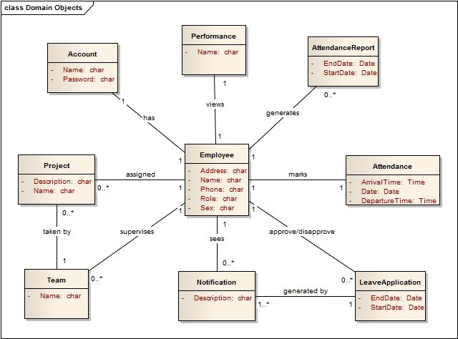

9. System Sequence Diagrams

Login

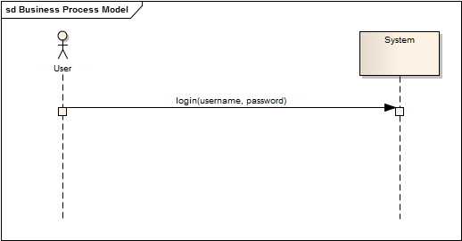

View user's attendance

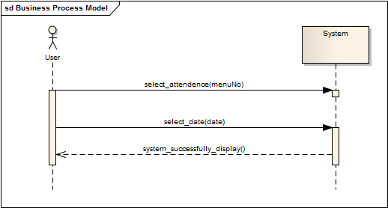

Apply for leave

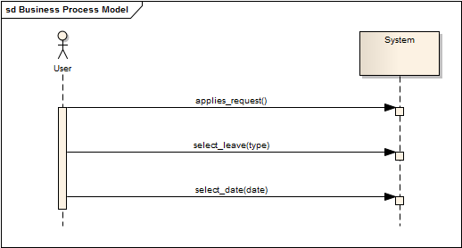

Approve/Disapprove leave applications
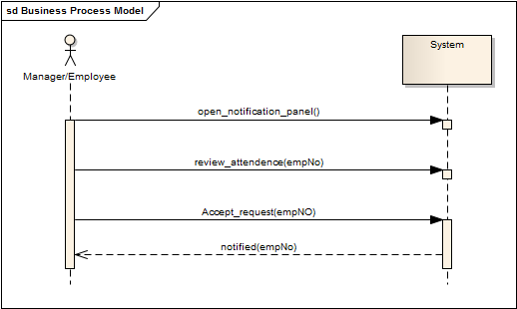

View team's attendance reported
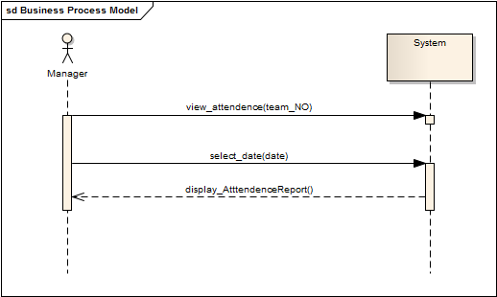

Generate enterprise-wide attendance reported

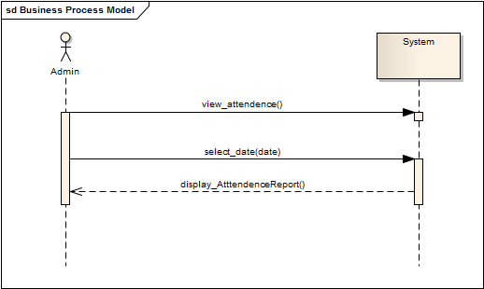

Generate late arrival report
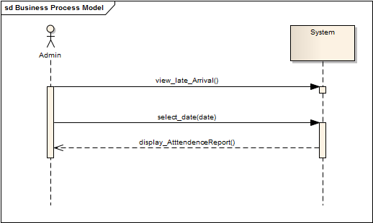

View employee's profile
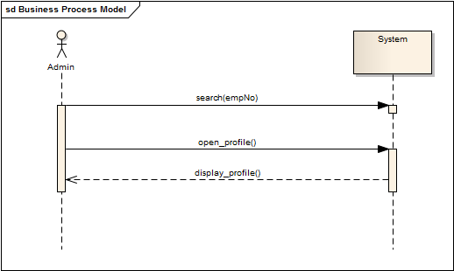

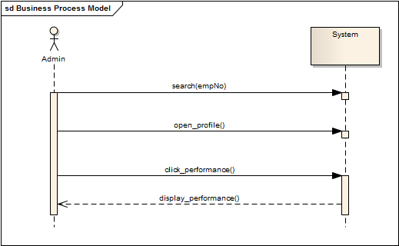
Review performance of an employee

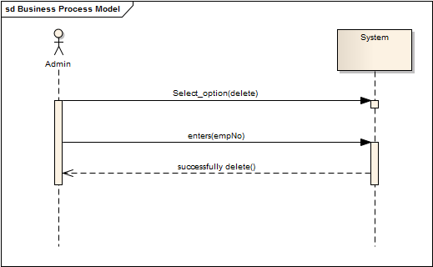
Create employee account

Delete employee account

Update account
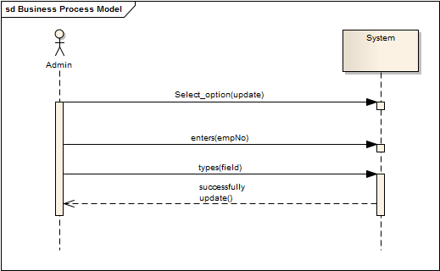

Assign a project to an employee
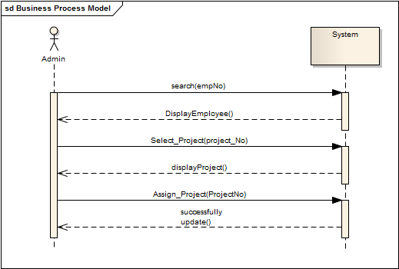

10. Operation Contracts

Operation Contract 1

Name: login(username, password)

Responsibility: Allow the user to login and view the interface.

Type: System

Cross Reference: RN 1, Login

Precondition: User must be registered. The account must not be disabled.

Post condition:
1.A Employee instance is created.

Operation Contract 2

Name: clicks(view_attendance)

Responsibility: To allow the user to view his attendance.

Type: System

Cross Reference: RN 2, View Attendance

Precondition: User must be signed in.

Operation Contract 3

Name: selectDate(Date)

Responsibility: To allow the user to choose specific dates.

Type: System

Cross Reference: RN 3, View Attendance, Apply for leave, View team's attendance, Generate
enterprise-wide attendance report, Generate late arrival report

Precondition: User must be signed in.

Postcondition: StartDate and endDate were updated.

Operation Contract 4

Name: applies_request( leaveType)

Responsibility: To allow the user to apply for leave.

Type: System

Cross Reference: RN 4, Apply for leave

Precondition: User must exist. The user must be logged in.

Postcondition:
1. An instance of leave application is created.
2 .A notification instance is created.
3. Manager was associated with notification.

Operation Contract 5

Name: selectLeaveType(leaveType)

Responsibility: To allow the user to select a leave type so the application can be sent.

Type: System

Cross Reference: RN 5, Apply for leave

Precondition: User must exist. The user must be logged in.

Operation Contract 6

Name: viewAttendance(E_ID)

Responsibility: To allow the manager to view attendance of the subordinate (also the applicant for
leave)

Type: System

Cross Reference: RN 6, Approve/Disapprove leave application

Precondition: Manager must be signed in.

Postcondition: StartDate and endDate were updated.

Operation Contract 7

Name: approveLeave(empID)

Responsibility: To allow the manager to accept/approve of the leave application

Type: System

Cross Reference: RN 7, Approve/Disapprove leave application

Precondition: Manager must be signed in.

Postcondition:
1. Manager was associated with leaveapplication..
2. leaveAccepted was set to true.

Operation Contract 8

Name: viewTeamAttendance(team)

Responsibility: To allow the manager to view his/her team's attendance

Type: System

Cross Reference: RN 8, View team's attendance report

Precondition: Manager must be logged in.

Postcondition:
1. An instance of team was created.
2. An instance of attendence report was created. 3. Manager was associated with team.

Operation Contract 9

Name: viewEnterpriseAttendance()

Responsibility: To allow the administrator to view the enterprise wide attendance report.

Type: System

Cross Reference: RN 11, Generate enterprise-wide attendence report

Precondition: Administrator must be signed in.

Postcondition:
1. An instance of attendence report was created.
2. Admin was associated with attendance report.

Operation Contract 10

Name: viewLateArrivals()

Responsibility: To allow the administrator to view the report of all employees who arrived late on or between selected date(s).

Type: System

Cross Reference: RN 10, Generate late arrival report

Precondition: Administrator must be signed in.

Postcondition:
1. An instance of attendence report was created.
2. Admin was associated with attendance report.

Operation Contract 11

Name: search(employee)

Responsibility: To allow the user to search for an employee.

Type: System

Cross Reference: RN 13, View employee profile, Review performance of an employee,View
Employee Profile, delete Employee Account, Update Employee Account

Precondition: User must be signed in.

Postcondition: EmployeeFound was set to be true.

Operation Contract 12

Name: openProfile(employee)

Responsibility: To allow the user to view the profile of an employee.

Type: System

Cross Reference: RN 12 View employee profile, Review performance of an employee

Precondition: User must be signed in.

Postcondition:
1. An instance of Profile was created.
2. Employee was associated with profile.

Operation Contract 13

Name: view_performance(employee)

Responsibility: To allow the manager to review performance of an employee.

Type: System

Cross Reference: RN 13, Review performance of an employee

Precondition: Manager must be signed in.

Postcondition:
1. An performance instance was created.
2. Performance was associated with employee.

Operation Contract 14

Name: addAccount()

Responsibility: To allow the administrator to add an account.

Type: System

Cross Reference: RN 14, Create employee account

Precondition: Administrator must be signed in.

Postcondition:
1. An account instance was created.
2. Admin was associated with Account.

Operation Contract 15

Name: deleteAccount(accountNO)

Responsibility: To allow the administrator to delete an account.

Type: System

Cross Reference: RN 15, Delete employee account

Precondition: Administrator must be signed in.

Postcondition:
1. An account instance was deleted.

Operation Contract 16

Name: updateAccount(Info)

Responsibility: To allow the administrator to update an account.

Type: System

Cross Reference: RN 16, Update employee account

Precondition: Administrator must be signed in.

Postcondition: All attribute of the Employee object were updated with the enter info.

11. Sequence Diagram
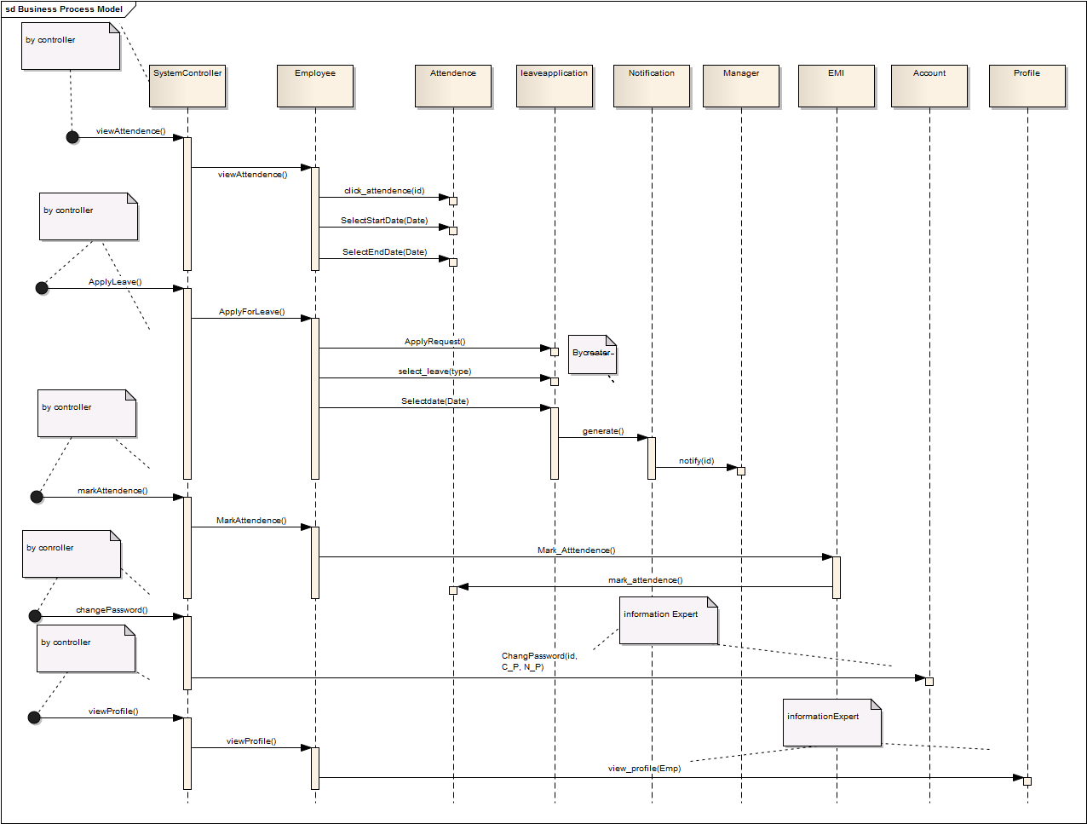

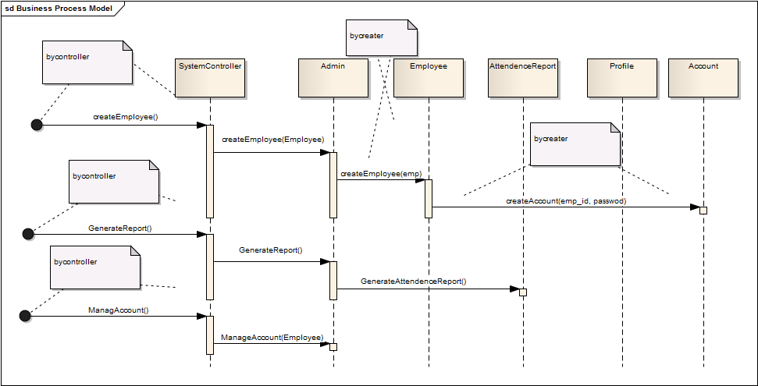

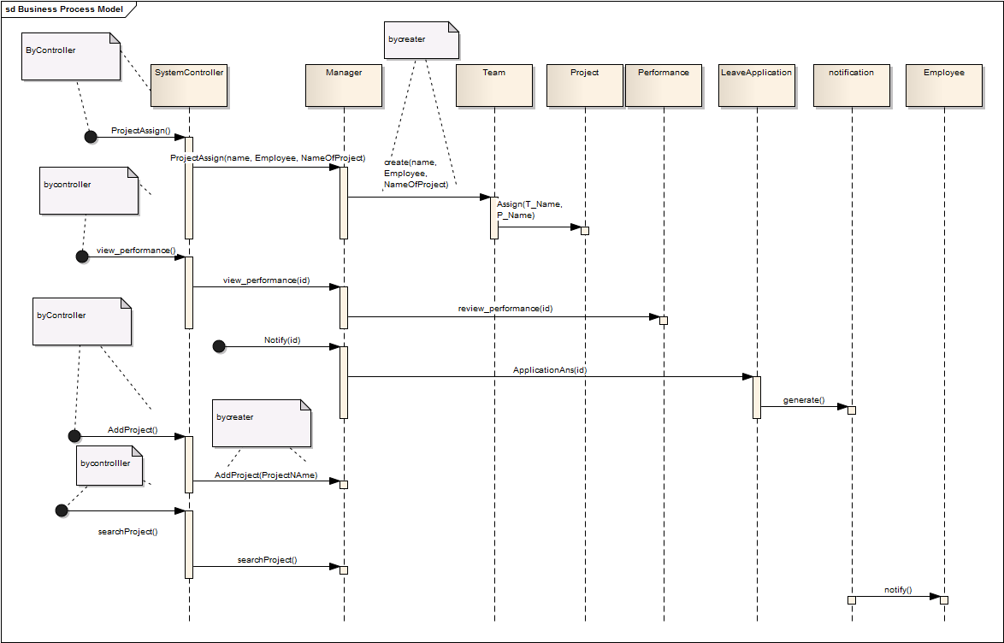

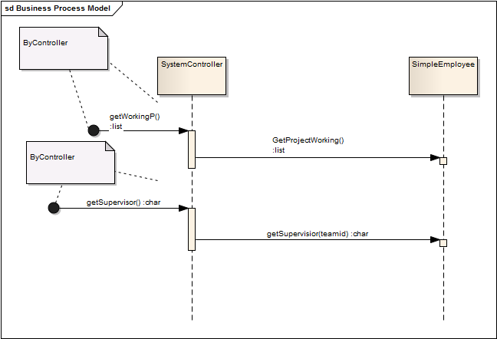

12. Class Diagram
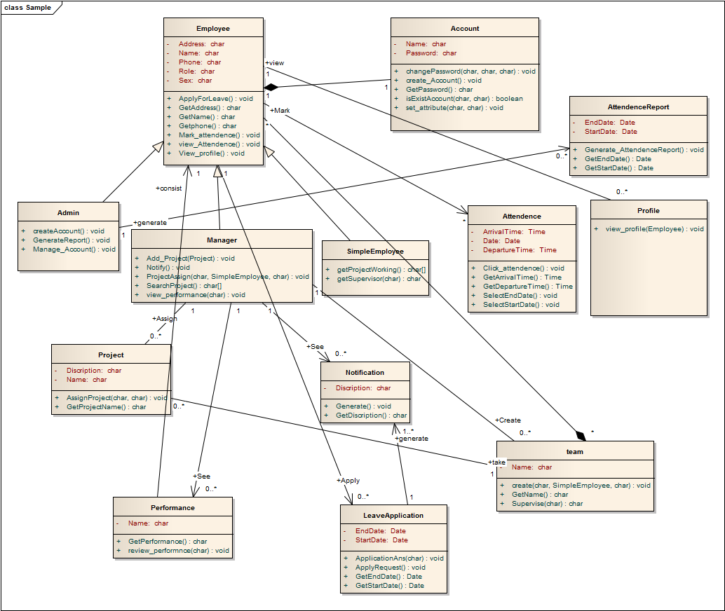

13. Package Diagram

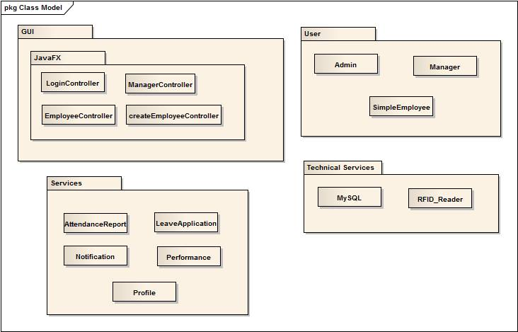

12. Deployment Diagram

